1. **Striate directions**

**Rose diagram of striae data from site RED 72**

**Figure 1.** Rose diagram generated from the first striae readings (site RED 72), which were measured off roche mountonee stoss surfaces at the Øksfjordjøkelen glacier, North Norway. Clasts are pointing mostly towards the south and slightly to the west.

**Rose diagram of striae data from site RED 73**

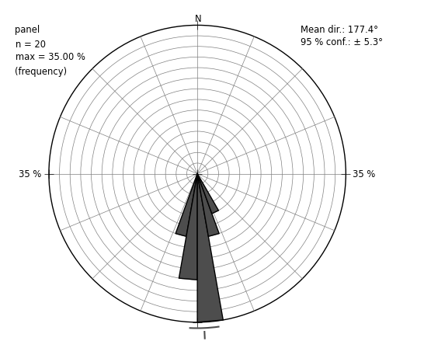

**Figure 2.** Rose diagram generated from the second striae readings (site RED 73), which were measured off roche mountonee stoss surfaces at the Øksfjordjøkelen glacier, North Norway. All clasts are pointing towards the south.

**Rose diagram of striae data from site RED 74**

**Figure 3.** Rose diagram generated from the second striae readings (site RED 74), which were measured off roche mountonee stoss surfaces at the Øksfjordjøkelen glacier, North Norway. Clasts are pointing mostly towards the south and slightly to the west.

**Rose diagram of striae data from site RED 75**

**Figure 4.** Rose diagram generated from the second striae readings (site RED 75), which were measured off roche mountonee stoss surfaces at the Øksfjordjøkelen glacier, North Norway. Clasts are pointing towards the south.

**Table 1.** Tabulated summary of the mean directions and +- 95% confidence interval from each striae data set.

|  |  |  |
| --- | --- | --- |
| **Striate Data** | **Mean Direction (°)** | **+- 95% Confidence Interval (°)** |
| **RED 72** | 189.2 | +-4.7 |
| **RED 73** | 177.4 | +-5.3 |
| **RED 74** | 188.4 | +-2.9 |
| **RED 75** | 180.8 | +-3.8 |

1. 2

**B**. There is only one ice flow because when considering +-95% confidence level, our data are overlapping. We can see only a very little variations, which might be caused rather by morphological changes of ice (e.g. ice thinning) than to assume there are two different phases of ice flows.

1. **Clast fabric plots**

**The crevasse squeeze ridge stereoplot**

**Figure 5.** Generated stereoplot from the crevasse squeeze ridge data collected at the foreland of Osbournebren in Svalbard. Principal eigenvector (green star) has a shallow depth and states dominant orientation (maximum clustering) of our data towards the north east.

**The sub crevasse squeeze ridge stereoplot**

**Figure 6.** Generated stereoplot from the sub crevasse squeezed ridge data collected at the foreland of Osbournebren in Svalbard. Points are mostly clustered around the edge, with the eigenvector 1 pointing towards the east and with shallow depth.

**Table 2.** Tabulated normalised eigenvalues (S1, S2, S3) for two different samples collected at the foreland of Osbournebren in Svalbard.

|  |  |  |  |
| --- | --- | --- | --- |
| **Sample** | **S1** | **S2** | **S3** |
| **Sample 1 (CSR)** | 0.532 | 0.265 | 0.203 |
| **Sample 2 (Sub-CSR)** | 0.477 | 0.362 | 0.161 |

**CSR and sub-CSR ternary eigenvalue plot**

**Figure 7.** Ternary eigenvalue plot showing the shape distribution based on eigenvectors calculated from the three axes of maximum, intermediate, and minimum clustering. Dataset was collected at the foreland of Osbournebren in Svalbard.

Both till samples are located in the middle of the eigenvalue plot, suggesting lower fabric strength, weaker ice bed coupling and less amount of shear strain. Fabric of both samples tends to incline towards isotropic distribution, where sample 2 (sub-CSR) has stronger inclination towards girdle fabric, whereas sample 1 (CSR) towards cluster fabric.

* 1. Flutes vs Mega Scale Glacial Lineations

1. **Flutes**

**True glacier centre stereoplot**

**Figure 8.** Generated stereoplot from the flute data collected on the centre of the true glacier at Brúarjökull, Iceland.

**True glacier left stereoplot**

**Figure 9.** Generated stereoplot from the flute data collected at the left side of the true glacier at Brúarjökull, Iceland.

**True glacier right stereoplot**

**Figure 10.** Generated stereoplot from the flute data collected at the right side of the true glacier at Brúarjökull, Iceland.

**Table 3.** Tabulated normalised eigenvalues (S1, S2, S3) for the three different samples from the foreland of Brúarjökull, Iceland.

|  |  |  |  |
| --- | --- | --- | --- |
| **Type of sample** | **S1** | **S2** | **S3** |
| **Centre sample** | 0.538 | 0.250 | 0.212 |
| **Right sample** | 0.393 | 0.316 | 0.290 |
| **Left sample** | 0.547 | 0.275 | 0.178 |

**Ternary eigenvalue plot of flute true glacier sample**

**Figure 11.** Ternary eigenvalue plot showing the shape distribution based on eigenvectors. Data were collected from the true glacier left, right and the centre of the flute from the foreland of Brúarjökull, Iceland.

In the case of centre and left samples, the dominant orientation of our clasts is almost to the center, with a slight inclination to the west. Clasts collected on the right side of the flute show direction to the south and east. The centre and left samples are a bit stiffer in comparison to the right one, which is almost at the top of the diagram. Ternary diagram for our clasts suggests loss fabric strength, weaker ice bed coupling, and less amount of shear strain. These facts correspond with the flute formation theory, where a boulder causes a barrier beneath the actively flowing glacier. After that, the glacier pushes heavily saturated sediment into a cavity on the boulder obstruction's leeside (Benn and Evans, 2010).

**4.MSGL**

**Stereoplot of AF1 (0.8-1m) clast fabric dataset**

**Figure 12.** Generated stereoplot from the first (AF1) dataset consisting of 30 clast fabric samples taken from MSGL Poznań, Poland.

**Stereoplot of AF4 (1.4-1.6m) clast fabric dataset**

**Figure 13.** Generated stereoplot from the second (AF4) dataset consisting of 30 clast fabric samples taken from MSGL Poznań, Poland.

**Stereoplot of AF5 (1.6-1.8m) clast fabric dataset**

**Figure 12.** Generated stereoplot from the first (AF5) dataset consisting of 30 clast fabric samples taken from MSGL Poznań, Poland.

**Table 4.** Tabulated normalised eigenvalues (S1, S2, S3) for the three different samples taken from MSGL Poznań, Poland.

|  |  |  |  |
| --- | --- | --- | --- |
| **Sample** | **S1** | **S2** | **S3** |
| **AF1 (0.8-1 m)** | 0.786 | 0.169 | 0.045 |
| **AF4 (1.4-1.6 m)** | 0.822 | 0.115 | 0.063 |
| **AF5 (1.6-1.8 m)** | 0.690 | 0.206 | 0.104 |

**Ternary diagram of MSGL fabric datasets from different depths**

**Figure 13.** Ternary eigenvalue plot showing the shape distribution of three (AF1 (0.8-1 m), AF4 (1.4-1.6 m), AF5 (1.6-1.8 m)) different datasets consisting of 30 clast fabric samples taken from MSGL Poznań, Poland.

Based on our data, we can say that our till is very stiff and has undergone relatively low strain. Fabric and ice bed coupling is super strong, clasts are all aligned to same direction. MSGLs have been discovered in front of and beneath ice streams, evolving during rapid ice flow (Spagnolo, 2014). A strong sediment is also thought to be required for the formation of MSGLs, which is proved by our results.

5. **Shape, RA & C40**

**Table 5.** Tabulated C40 and the RA (roundness angularity) for 11 datasets each consisting of 30 clasts. Data come from the on and around Sydbreen a glacier in the Lyngen Alps, North Norway.

|  |  |  |
| --- | --- | --- |
| **Sample** | **C40** | **RA** |
| **NO2** | 43.33 | 46.67 |
| **NO4** | 23.33 | 20.00 |
| **NO5** | 13.33 | 10.00 |
| **NO6** | 20.00 | 13.33 |
| **NO7** | 56.67 | 76.67 |
| **NO8** | 23.33 | 30.00 |
| **NO11** | 46.67 | 70.00 |
| **NO12** | 13.33 | 20.00 |
| **NO16** | 53.33 | 73.33 |
| **NO17** | 56.67 | 56.67 |
| **NO22** | 26.67 | 0.00 |

**Relationship between RA, C40 and different types of sediments**

**Figure 14**. Cross-plot identifying different sediment types collected from Sydbreen glacier in North Norway.

The highest proportion of very angular and angular sediments could be found in category supraglacial, crevasse fill and moraine. Significantly rounded rocks which were actively transported and underwent morphological changes as they travelled further are in groups till, subglacial flute and fluvial.

**6. Drumlin orientation**

**Drumlins rose diagram**

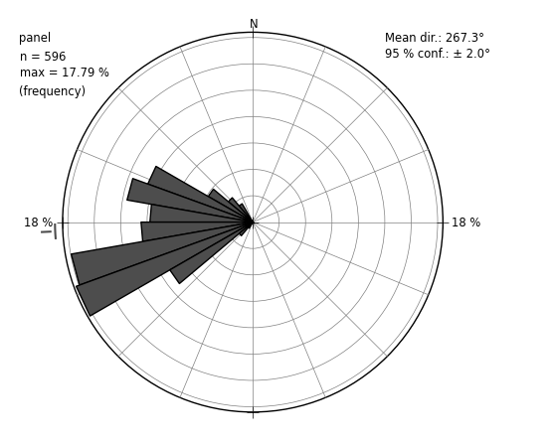

**Figure 15.** Overall azimuthal distribution of 597 mapped drumlins in NW Cumbria.

Drumlin’s azimuthal data suggests that direction of palaeo ice flow was towards west, however, because drumlins are bidirectional glaciers landforms, we can be certain about orientation east west or vice versa (Hughes et al., 2010).

**References**

Benn, D.I., and Evans, D.J.A., 2010. Glaciers and Glaciation. Hodder-Arnold, London.

Hughes et al., 2014. Flow-pattern evolution of the last British Ice Sheet. Quaternary Science Reviews, 89, 148-168

Spagnolo, M., Clark, CD., Ely, JC., Stokes, CR., Anderson, JB., Andreassen, K., Graham, AGC. & King, EC. (2014). 'Size, shape and spatial arrangement of mega-scale glacial lineations from a large and diverse dataset'. Earth Surface Processes and Landforms, vol 39, no. 11, pp. 1432-1448.